Jonathan Millar (166056

rESEARCH AND DESIGN

Introduction and initial ideas

At the start of the this project the first thing I decided to do was to look around and see what type of website I would like to build my website about. Using the brief of brand and music groups I decided on music groups as I think that music websites offer a lot more creative freedom than other types of websites, with more room to explore a larger variety of features. I quite like the idea of darker colour pallet as I find them easier to work with than bright colours. The site should be focused on functionality and try to be as clean as possible with subtle complexity as not to overshadow the facilities consumers might come to the website for such as: tour dates/merchandise/album content/band information. I like the way most music websites do their home pages with the landing page being where a very large majority of the focus is, so I think I will try and accomplish something similar with my own.

Mood board

I really like the orange/yellow colour pallets with blacks and gray so I think I will make the primary colour/navigation colour of my website a yellowish colour and the non-focus elements gray/black.

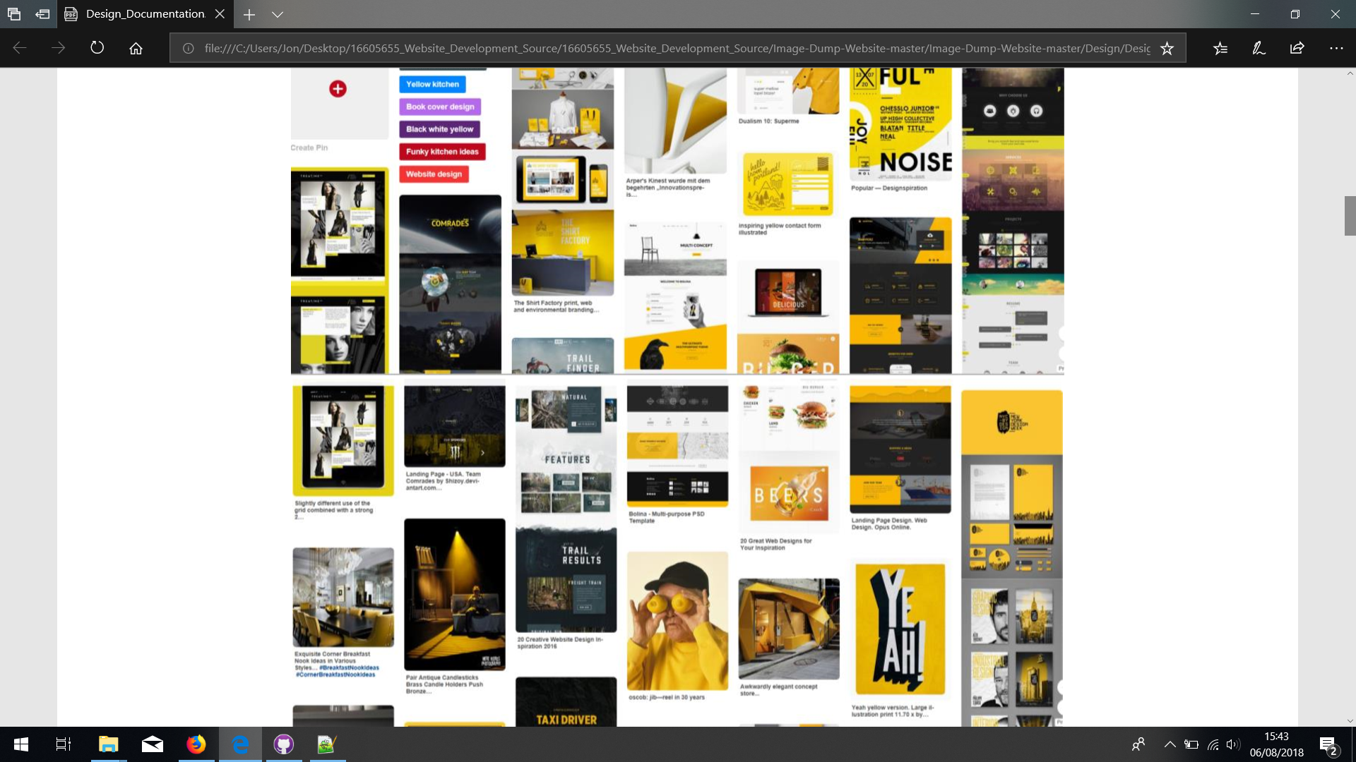

**Research**

In this segment, I will attempt to highlight things I like and dislike about other music websites and consider how I could implement them into my own or replace them entirely. I looked at 2 different websites, 1 of which I really like and then 1 I don’t like.

**Analysis of Metallica’s Website**

The colour pallet of the navigation is quite dull at first glance but what I really like about it is that there is a large contrast in colours between the content and the navigation bars/background. Content is separated very effectively, and navigation seems simple. The site makes heavy use of drop down menus none of which I think are too invasive. Animations and transitions are smooth and easy of the eye and aren’t intensive. No in your face videos or animations which is considerate for users with older equipment and poor internet connections. All things considered there is not much I would change with this website. The only thing I think I would like to change to include in my website would be a sticky navigation bar at the top of the screen to keep navigation consistent. I am also a big fan of having links focus of a target element which this site does not do so I think I would like to do that too. The website is very flexible and dynamic which I really like and would like to try and incorporate into my own.

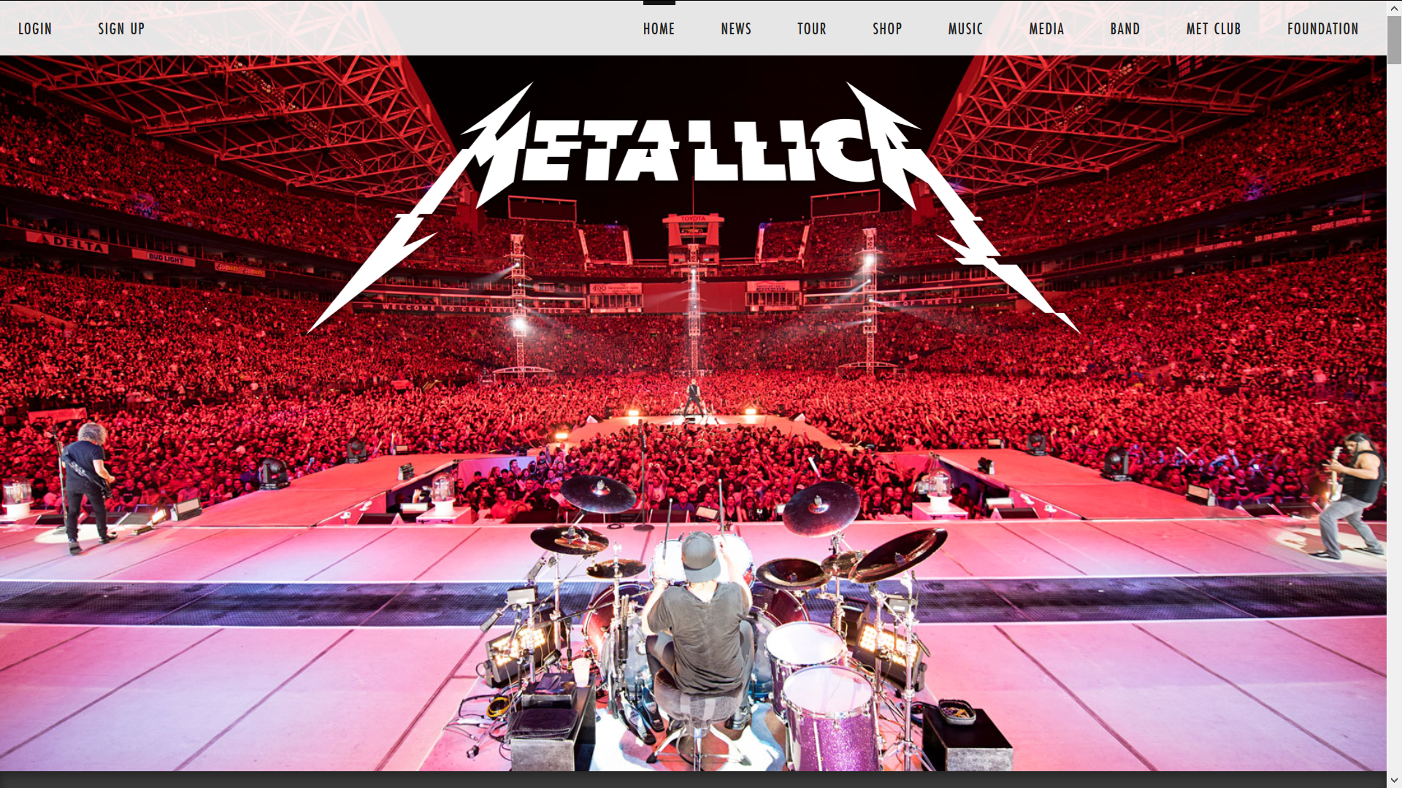

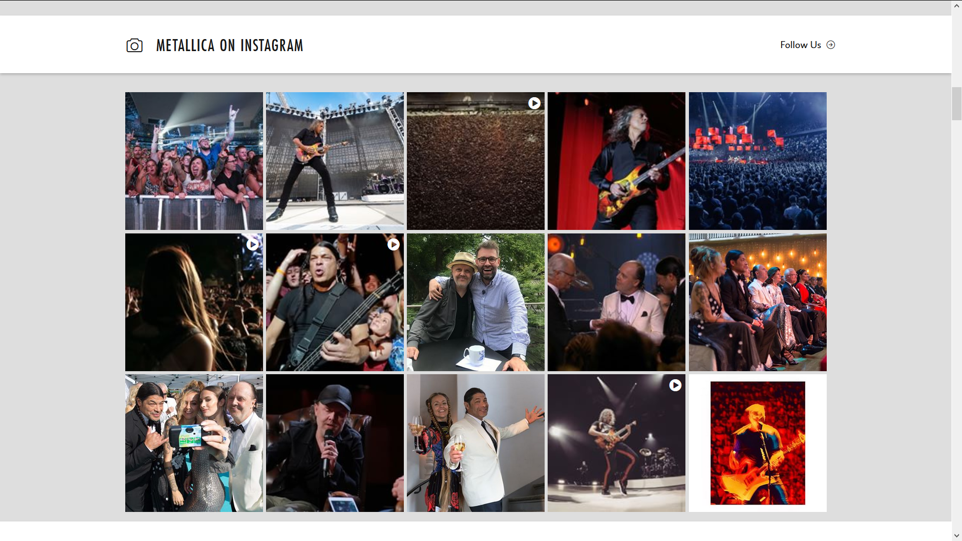

Without Drop-down Menu:

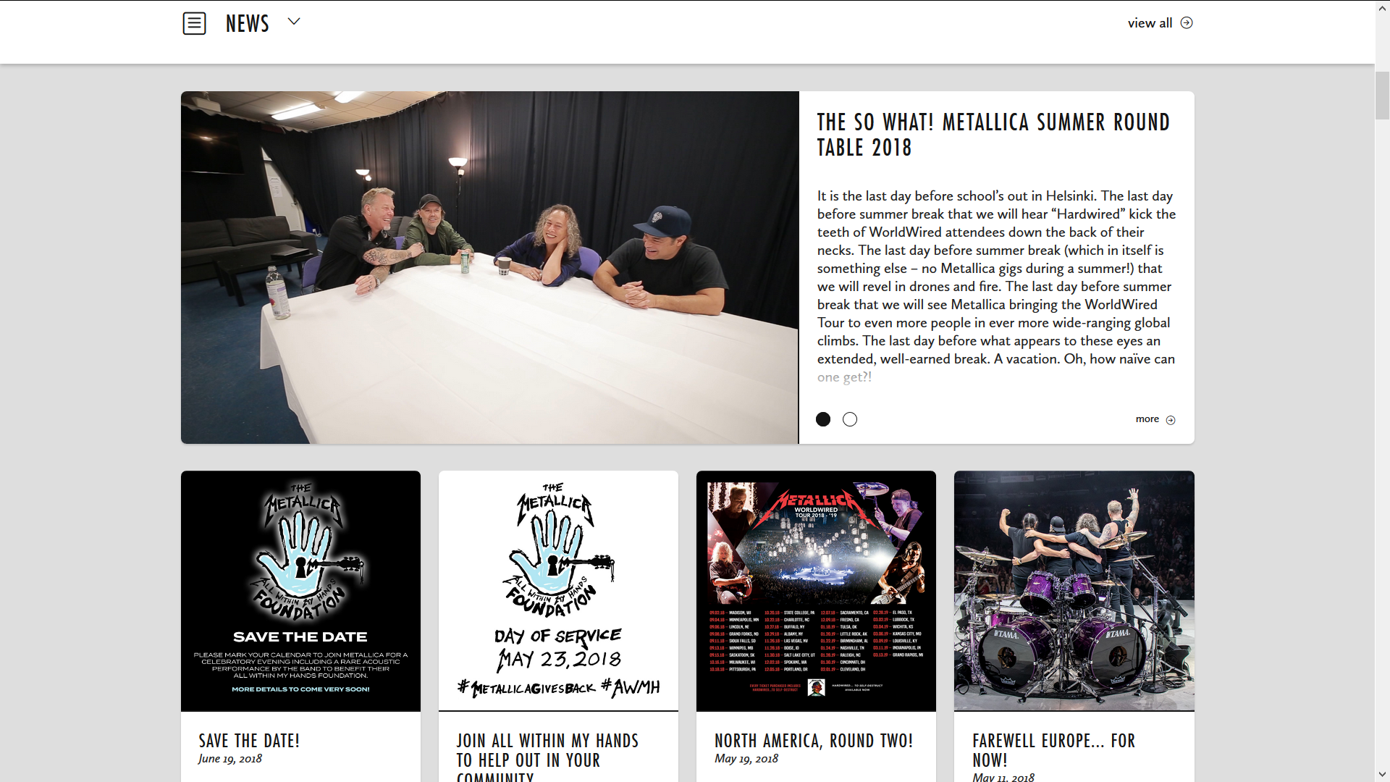

With Drop-down Menu:

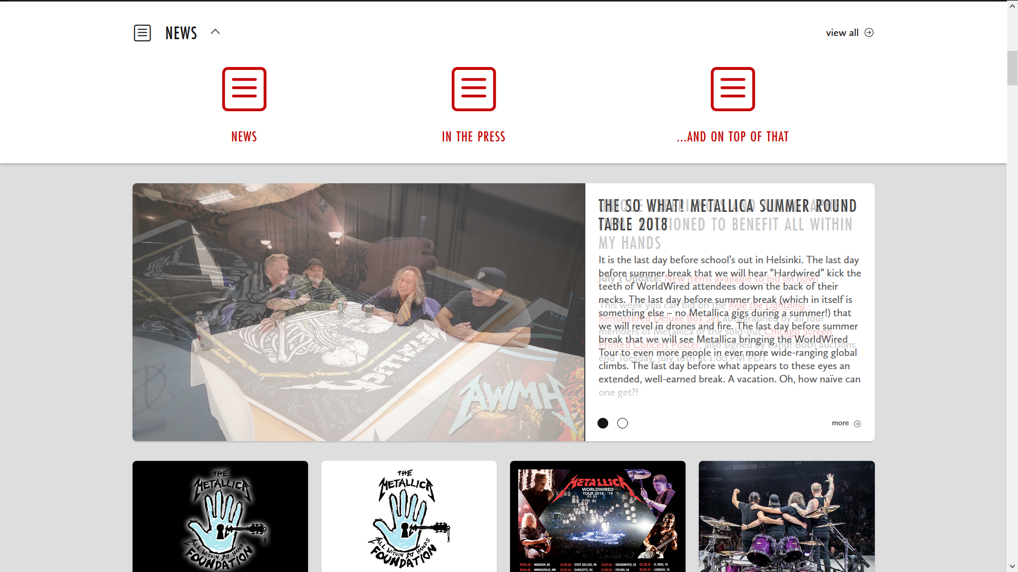

**Analysis of Panic At The Disco’s website**

I don’t like panic at the disco’s website as much, the navigation bar is quite small and hard to see, along with the other navigation options on the screen. There isn’t a lot of content on the landing page, which can be both a positive and a negative. The positive that this site has it looks like the navigation options look like they would translate very nicely to mobile/tablet devices. The interoperability is a large part of this project so that is something I should try and take on board.

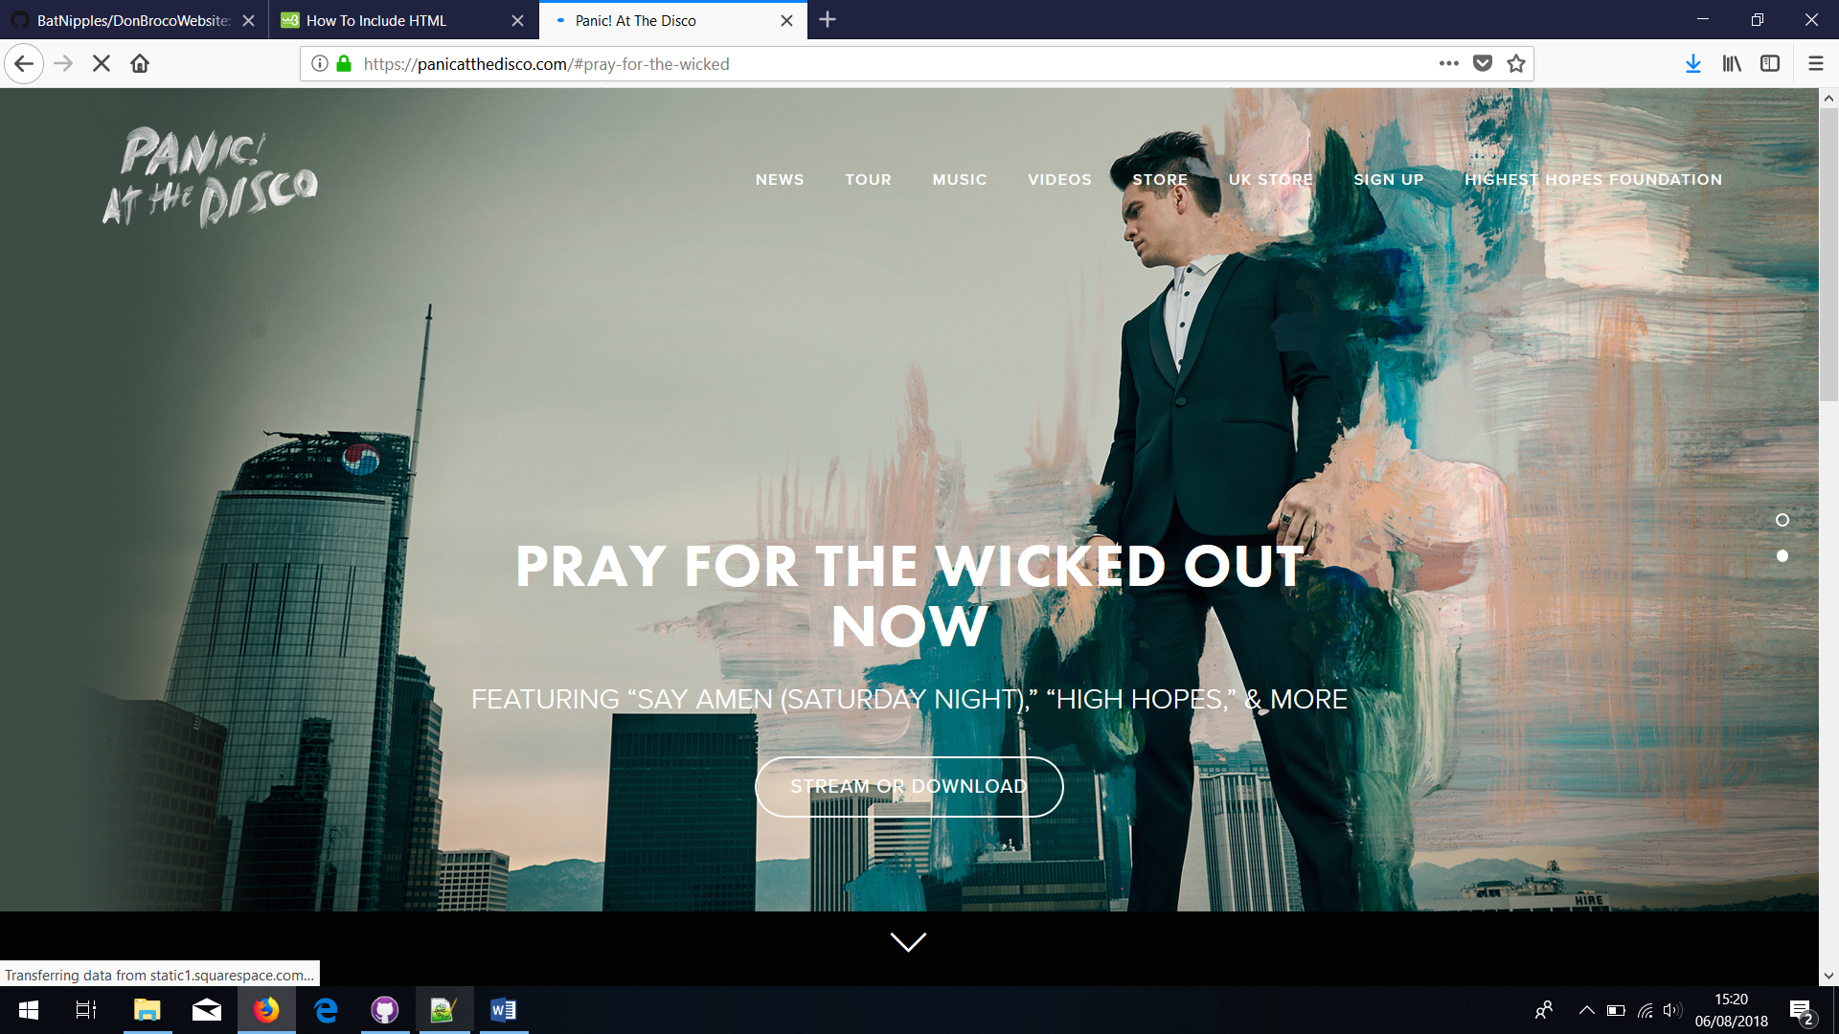

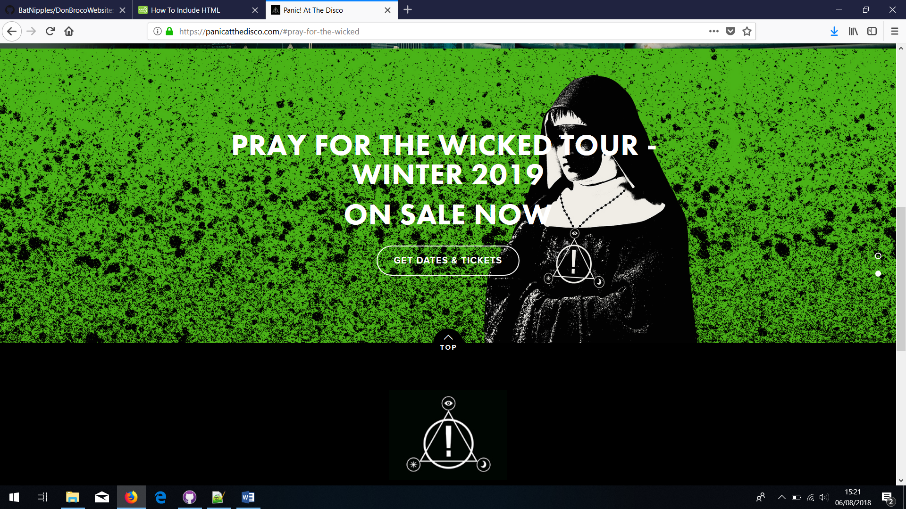

**Website Skeleton frame/wiremodel**

First screen the user sees when the page loads in. Contains both mobile and standard navigation options.

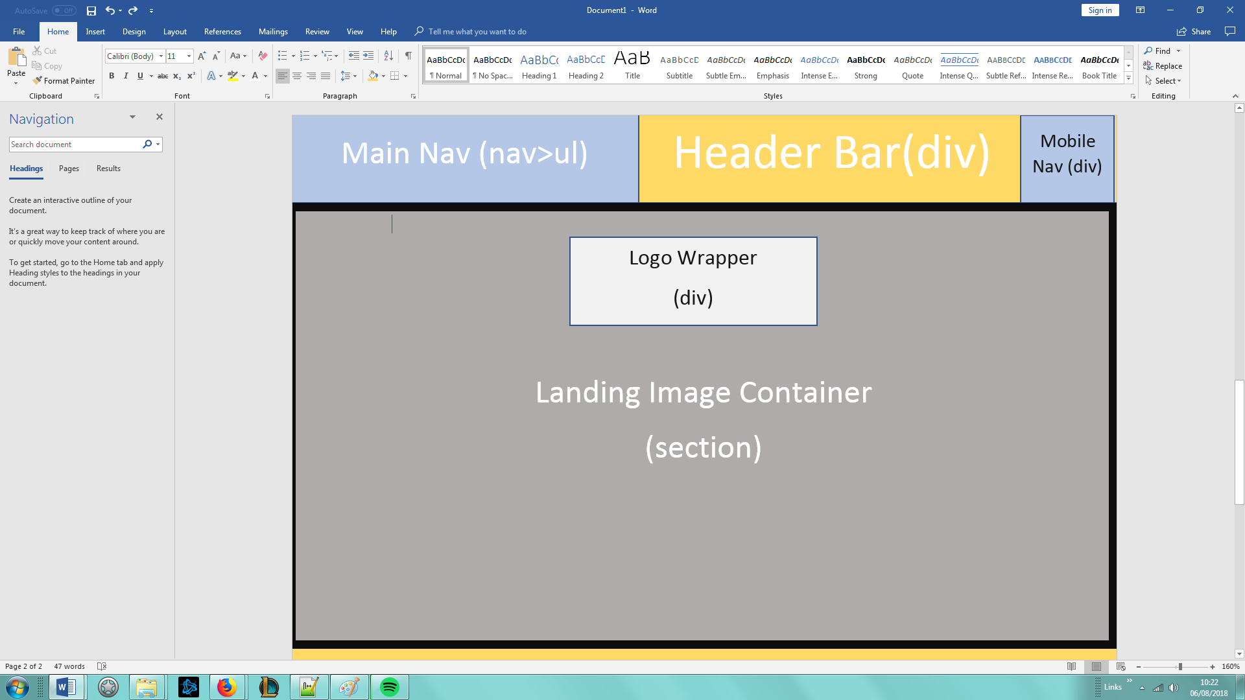

Second screen the user sees. Contains 3 of the bands albums with a track selector.

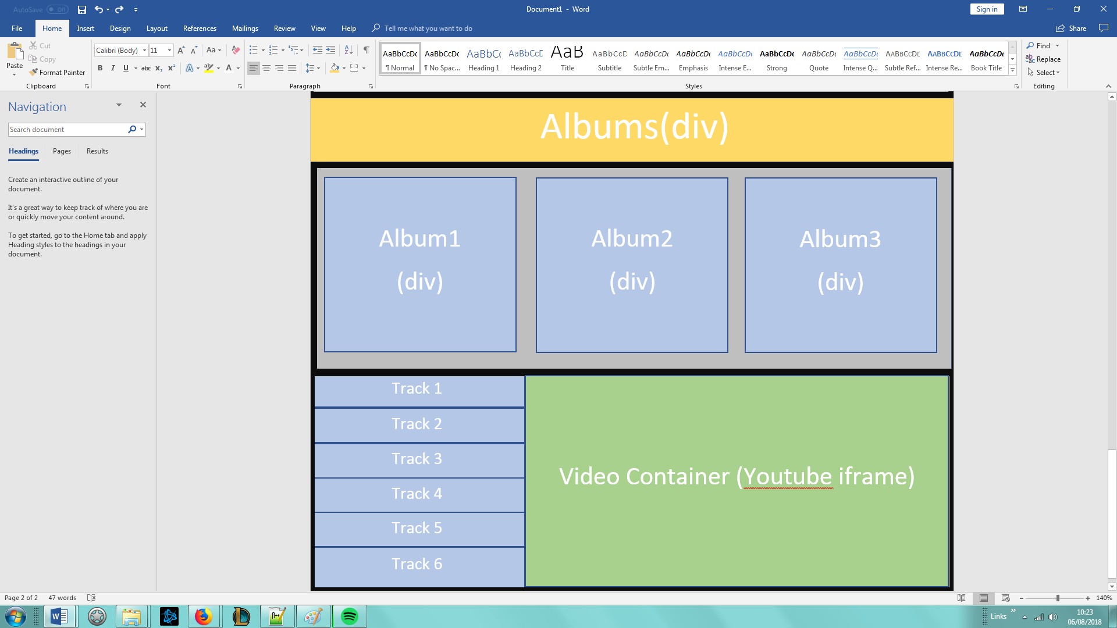

Third screen the user sees. Contains a slide show and a link to the customizer.

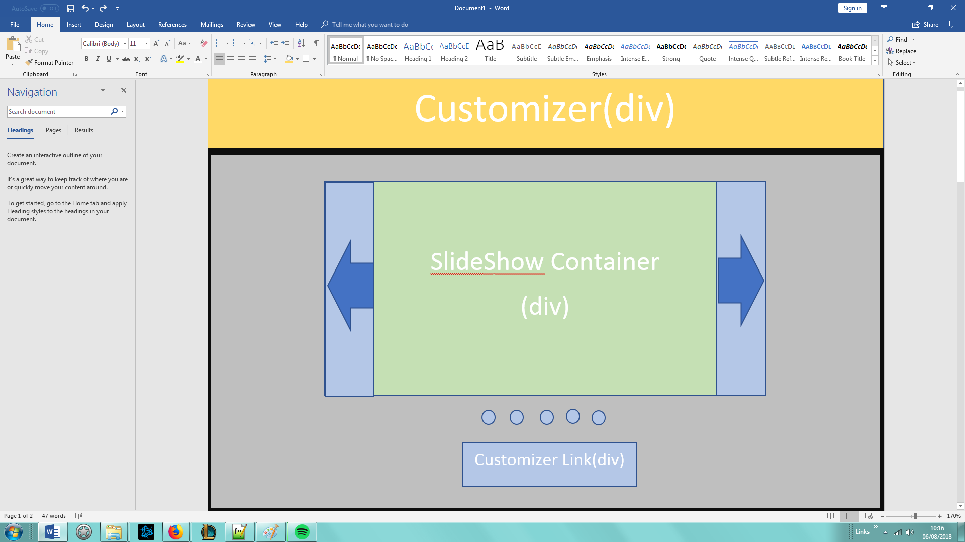

Fourth screen the user sees. Contains a link to the report.

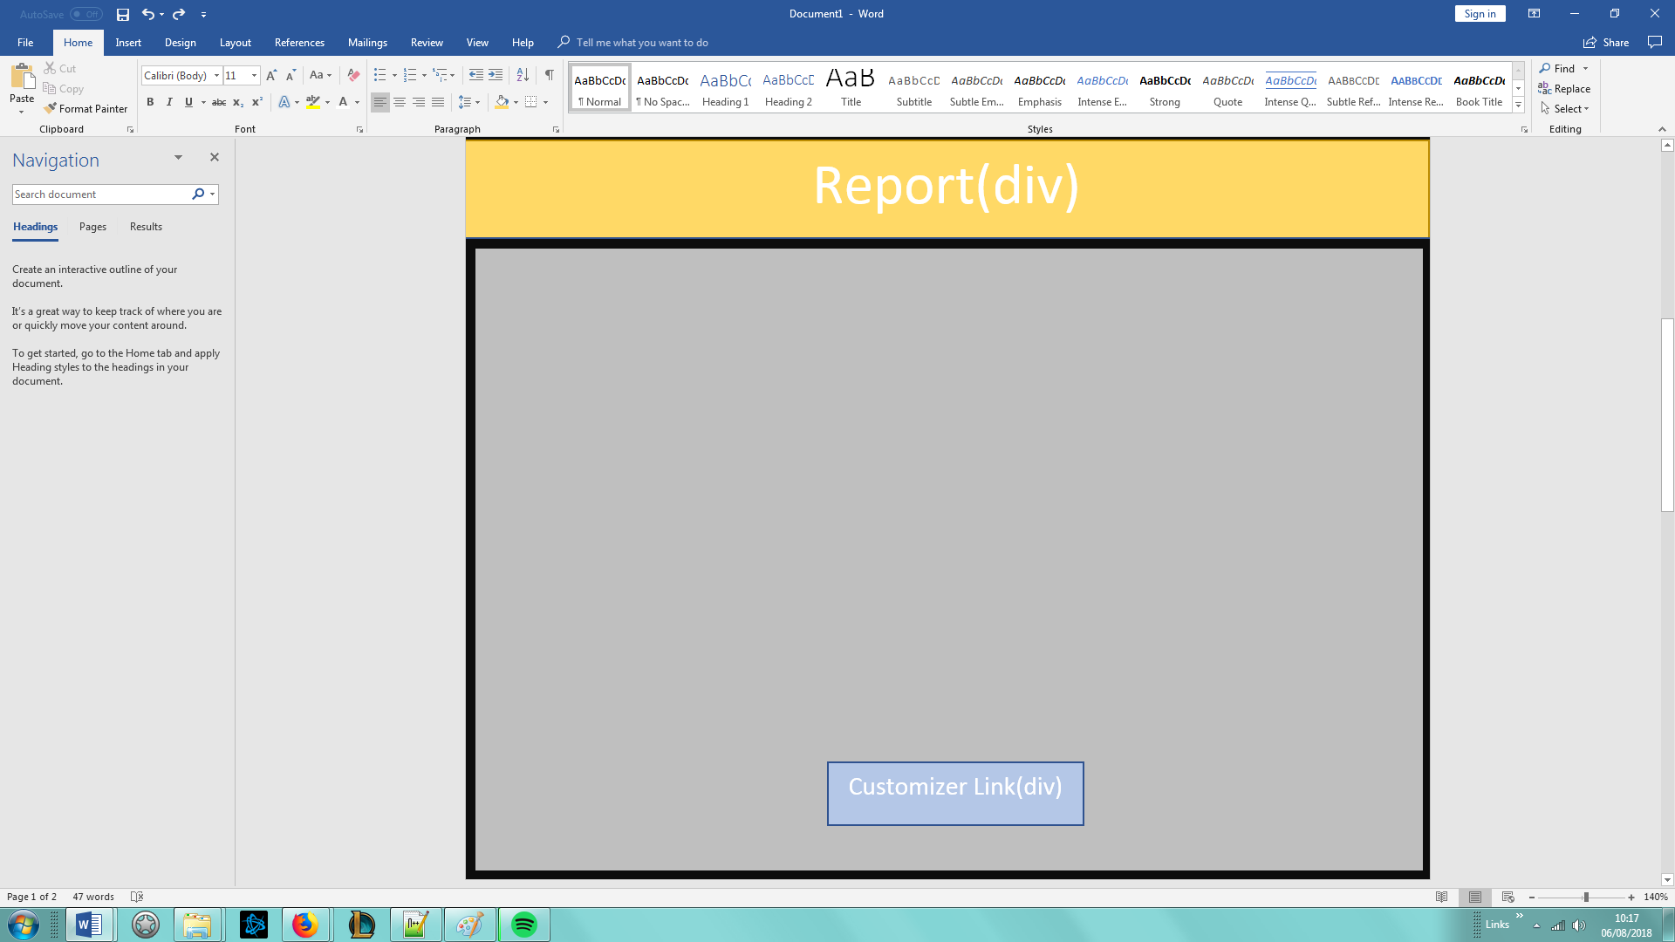

Mobile Navigation. Fullscreen navigation with a transparent background only available on small tablets and mobile device screen sizes.

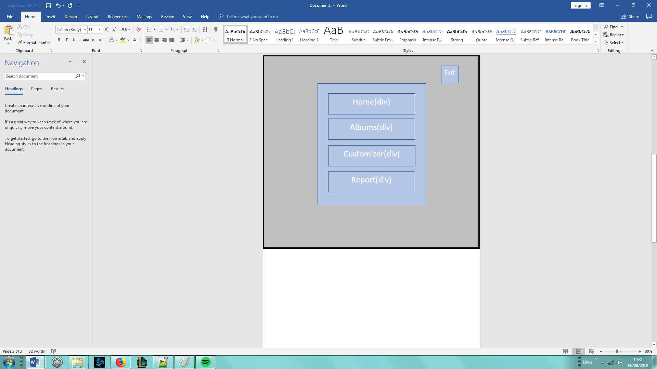

Canvas webpage. The user will see this page after clicking on the link in the customizer section of the index page.

